

QUESTION PAPER GENERATOR

PROJECT SPECIFICATIONS & IMPLEMENTATION METHODOLOGY

Version 1.0 5/Mar/2023

Development Team members

|  |  |
| --- | --- |
| ***HALL TICKT NO.*** | ***NAMES*** |
| *2029258054019* | *J. Supriya Lakshmi* |
| *2029258054020* | *J. Ramya Rupa* |
| *2029258054022* | *K. Dhanesh* |
| *2029258054023* | *K. Achyuth* |
| *2029258054024* | *K. Anand Babu* |
| *2029258054025* | *K. Rama Devi* |
| *2029258054026* | *Md. Sameer* |
| *2029258054027* | *M. Naga Suseela* |
| *2029258054036* | *P. Sumanth* |
| *20229258054041* | *Sk. Habeebunnisa* |
| *2029258054046* | *V.U.V. Anitha* |
| *2029258054049* | *V. Sri Anjani Devayani* |
| *2029258054051* | *Y. Gayathri* |
| *2029258052023* | *M. Bhargavi* |
| *2029258052036* | *P. Naga Bramarambha* |

**Table of Contents**

**1. ABSTRACT …… 4**

**2. INTRODUCTION …… 9**

**3. PROBLEM STATEMENT …… 10**

**4. EXISTING SYSTEM …… 11**

**5. PROPOSED SYSTEM …… 12**

**6. OBJECTIVE …… 13**

**7. PROJECT CATEGORY …… 14**

**8. SCOPE OF THE SYSTEM …... 15**

**9. KEY FEATURES ……. 16-18**

**10. THE PROPOSED METHODOLOGY …… 18-19**

**11. IMPORTANCE …… 19-21**

**12. DEVELOPMENT LIFE CYCLE ….. 21-24**

**13. PROJECT MANAGEMENT METHODOLOGY ….. 25**

**14. DESIGN CONSIDERATIONS ….. 26-29**

**15. DEVELOPMENT METHODS & CONTINGENCIES ….. 30-31**

**16. DETAILED DEVELOPMENT PROCESS ….. 32-36**

**17. REGISTRATION-PAGE ….. 37-39**

**18. LOGIN ….. 39-41**

**19. HOME PAGE ….. 42-44**

**20. GENERATE PAPER ….. 45**

**21. GENERATED PAPER ….. 46**

**22. MOCK TESTS ...… 47-51**

**23. RESULT PAGE …. 52-53**

**24. FEASIBILITY STUDY ...… 53-54**

**25. TESTING / QA / UAT ….. 54-56**

**26. PROCESS DIAGRAMS …… 47-63**

**27. SECURITY …… 64**

**28. SAMPLECODE …… 65-68**

**29. FUTURESCOPE ….. 69**

**30. IMPLEMENTATION AND MAINTENANCE …… 70**

**31. CONCLUSION ……. 71**

**32. BIBOLOGRAPHY …... 71**

1. **ABSTRACT**

Question Paper Generator is special and unique software, which is used in school, institutions, colleges, test paper setters who want to have a huge database of questions for frequent generation of question paper. This software can be implemented in various medical, engineering and coaching institutes for theory paper.

You can create question paper with the software anytime within seconds. You can enter unlimited units and chapter depending upon the system storage, capacity and as per the requirement. For entering questions you have to first specify the paper name, questions, options and other details regarding it. This will be saved in the database and displayed as a question paper.

Many parents stress about their children and their grades. They want to make their children prepared for the test. This service can make it easy for them to prepare the question paper and do their work as well.

This site also provides mock test papers so that students can practice a lot before writing a real test in this competitive world.

A Project report on

**QUESTION PAPER GENERATOR**

**BACHELOR IN SCIENCES**

Submitted by

J. Supriya Lakshmi- 2029258054019

J. Ramya Rupa- 2029258054020

K. Dhanesh- 2029258054022

K. Achyuth- 2029258054023

K. Anand Babu- 2029258054024

K. Rama Devi- 2029258054025

Md. Sameer- 2029258054026

M. Naga Suseela- 2029258054027

P. Sumanth- 2029258054036

Sk. Habeebunnisa- 20229258054041

V.U.V. Anitha- 2029258054046

V. Sri Anjani Devayani- 2029258054049

Y. Gayathri- 2029258054051

M. Bhargavi- 2029258052023

P. Naga Bramarambha- 2029258052036

**Under the Guidance**

**Of**

**Nagamalleswararao T M.Tech**

PINKMOON Technologies Private Limited, Vijayawada



DEPARTMENT OF SCIENCE

SSR DEGREE COLLEGE

(Autonomous, Affiliated to Krishna University, Machilipatnam)

2022-2023

**SSR DEGREE COLLEGE**

DEPARTMENT OF SCIENCES



**CERTIFICATE**

This is to certify that project report titled Question Paper Generator is the bonafide work of ______________________________ bearing __________ in III B.sc (MSCS) V-semester computer science in partial fulfillment for the award of Bachelor in Sciences.

The results in the report have not been submitted to any university for the any degree.

**Signature of the guide**  **Signature of H.O.D**

**Signature of examiner**

**DECLARATION**

I hereby declared that the work is being presented in this thesis entitled.

“**QUESTION PAPER GENERATOR**” submitted towards the partial fulfillments of requirements for the award of the degree of **Bachelor of Sciences** is an authentic record of my work carried out under the supervision of **Nagamalleswararao T,(M-Tech), PINKMOON Technologies Private Limited**, Vijayawada. The matter embodied in this dissertation report has not been submitted elsewhere for any other degree. Furthermore, the technical details furnished in various chapters of this report are purely relevant to the above project and there is no deviation from the theoretical point of view for design, development, and implementation.

**Submitted by**

|  |  |
| --- | --- |
| *2029258054019* | *J. Supriya Lakshmi* |
| *2029258054020* | *J. Ramya Rupa* |
| *2029258054022* | *K. Dhanesh* |
| *2029258054023* | *K. Achyuth* |
| *2029258054024* | *K. Anand Babu* |
| *2029258054025* | *K. Rama Devi* |
| *2029258054026* | *Md. Sameer* |
| *2029258054027* | *M. Naga Suseela* |
| *2029258054036* | *P. Sumanth* |
| *2029258054041* | *Sk. Habeebunnisa* |
| *2029258054046* | *V.U.V. Anitha* |
| *2029258054049* | *V. Sri Anjani Devayani* |
| *2029258054051* | *Y. Gayathri* |
| *2029258052023* | *M. Bhargavi* |
| *2029258052036* | *P. Naga Bramarambha* |

**ACKNOWLEDGEMENT**

I would like to articulate my profound gratitude and indebtedness to my guide **Nagamalleswara Rao** who is has been a constant motivation and guiding factor throughout the project time in and out as well. It has been a great pleasure for me to get an opportunity to work under her guidance and complete the project successfully.

I would like to thank Science Department, SSR Degree College for supporting my work throughout the project period with all patience and understanding giving valuable inputs wherever required for betterment and result oriented work.

I also express my gratitude to our principal **Angel Xavier** for his encouragement and facilities provide during the course of the project.

I am also grateful to our staff members of the college for co-operating with me throughout the project*.*

J. Supriya Lakshmi- 2029258054019

J. Ramya Rupa- 2029258054020

K. Dhanesh- 2029258054022

K. Achyuth- 2029258054023

K. Anand Babu- 2029258054024

K. Rama Devi- 2029258054025

Md. Sameer- 2029258054026

M. Naga Suseela- 2029258054027

P. Sumanth- 2029258054036

Sk. Habeebunnisa- 20229258054041

V.U.V. Anitha- 2029258054046

V. Sri Anjani Devayani- 2029258054049

Y. Gayathri- 2029258054051

M. Bhargavi- 2029258052023

P. Naga Bramarambha- 2029258052036

**2. INTRODUCTION**

Many institutions have struggle preparing a question paper or saving the details of a question paper properly. For this we created a question paper generator site which generates the questions in the table format. You can access this paper whenever you feel like conducting an exam.

So for all prospects, it is one of the great and innovative tasks. Paper generation makes all tasks very simple and less time-consuming. As we can save lots of saving so educators can focus on the progressive part of the student. This tool helps to design test papers and manage all sections very carefully. It is a very supportive tool for all educators.

Also many times parents want to help their kids prepare for an exam but they couldn’t do it because they don’t have enough time to sit and write the whole question paper. So even parents can just come to site and enter required questions in the question paper generator and the questions are created automatically.

Our site also provides sample exam papers of different company recruitment tests. We created this website so that the students trying to get a job can practice the tests provided and do their best. We want to reach out the vast community of people trying to get a job.

This site is developed using PHP and MYSQL backend. The front-end of the application is made interactive using HTML, CSS, bootstrap.

**3. PROBLEM STATEMENT**

Traditionally question papers were generated manually. Preparing any exam paper is a very challenging task for the educators because they have to check whether there is any repetition in the pattern or not, and other than that security is one of the major concerns for them , also due to lack of teaching staff in any institute, creation of paper is not at all an easy task. So, here we are proposing an Question Paper Generator System which provides storage of the data, fast operations, and high security for all its tasks. It can be helpful to many educational as well as NGO institutes. Tasks performed by this system are automated and because of that storage space, security is not a concern anymore. Proposed system works upon Natural Language Processing and is fast due to computer based automation, streamlined, randomized and unbiased, secure and generates unique questions and overcomes the problems of Human based paper generation.

We have also put mock test papers which help the students get their desired jobs. We also want to put more exams so that the candidates can do better.

**4. EXISTING SYSTEM**

The main task is to create questions automatically based on the given text, i.e. sentences or groups of sentences. The basic input is a positive or declarative sentence or group of sentences. The output should be different kinds of questions depending on the type of sentences. Basically we can say that the input would simply be the text whereas output would be a number of questions. The basic goal of this system is to offer a solution to the problem of first breaking down the paragraph and then turning it into questions. There are different types of problems that exist in the current manual system of question paper generation. These problems are:-

● Low security as paper is not secured using any mechanism.

● Patterns or repetitions may occur in paper.

● Slow as human labor is involved.

● Mock test results are not stored in the database.

● Less variety of different types of questions. Thus there are many problems associated with manual human based question paper generation, therefore to overcome this we came up with ‘Question Paper Generator’.

**5. PROPOSED SYSTEM**

In today’s ambition, examination plays an important role in ensuring students’ academic progress and the era of information technology is now being replaced by the productive application of technology. In the "information society" the production of utility from knowledge is important for the development of society. For various examinations conducted in any academic course in one year, teachers are required to make a variety of question papers as per the guidelines and evaluation requirements of the autonomous college. It is a tough task for the teachers to cover all the characteristics of the course results and avoid duplication of questions in successful exams. Many times, this entire element may degrade the standard of the question paper. Automated creation of exam paper provides a platform to create a streamlined exam paper and at the same time automation is easy to incorporate many elements that determine the quality of the question paper. An efficient question paper is generally suitable for ordinary students, but it also engages the demanding item for clever students. Thus automatically creating a question paper from a description entered by a teacher uses a word-labeled question bank that is currently required by the hour. Here we are implementing a system which accordingly creates the question paper from this semantically labeled question bank. It is necessary to categorize queries as different class of queries need different methods for automatic generation of Question-type

● Yes/No Questions: also known as polar questions, whose expected answer is either yes or no.

● Wh-Questions: Wh-questions use interrogative words, such as why, when, who, where, what, which, etc., to request information.

● Fill-in-the-blanks Questions: also known as cloze questions. Fill-in-the-blank questions could be a sentence with one or a lot of blanks in it with four alternatives to fill those blanks

**6. OBJECTIVE**

The objective of this development effort is:

* To generate question papers in a faster manner.
* To provide accurate content to the user.
* Save the user details after registration in the database.
* When user clicks on the login button after enter they can enter the site.
* To make it less stressful as many educational institutions or companies have to take care of different other company related work.
* Saving the questions after entering in the form in the database.
* Displaying it in the question paper format so that the user can print the paper.
* Also provide latest mock tests so that the students can prepare for these exams.

**7. PROJECT CATEGORY**

This project is basically categorized as RDBMS. The project is based on three tier architecture. The three tier architecture where the application is divided into three logical constituents.

* 1. • Presentation layer o In this layer mainly following pages contained:
  2. o Web Pages
  3. o User Control
  4. o Master Pages
  5. • Business Layer
  6. o Business Logic,
  7. o Result Engine
  8. o User permissions logic
  9. o Access Rights
  10. • Data Layer

Provide handling and validation of data (MS SQL Server in this case).

* 1. o SQL
  2. o Sybase
  3. o Oracle12
  4. o Access

**8. SCOPE OF THE SYSTEM**

The scope of the system is defined on various functionalities provided by the system. The scope can be explained as:

* Information handling of the users i.e. new accounts created, data retrieval, letting user login to the application.
* Trying to build a web based system.
* Also trying to reduce manually made mistakes.
* Let the user enter the details of the question papers and questions in the forms.
* Store the details in entered in the database.
* Display the questions when the user clicks on the display button.
* Also make the mock test as similar as possible to the original test so that the user will take the site seriously.

**9. KEY FEATURES**

The examination process is very important for any organization. It can assess the performance of all students. It would also determine the quality of all students. Although it is a very time-consuming and challenging task for all the instructors. This system has several beneficial modules. It can increase the less chance of error and it has a great interface with perfect security.  
Here we will discuss some of the benefits of this paper generator:

### 1. Great interface:

This system shows all the basic characteristics of a system. It has a great interface to handle the overall task. In fact, it can generate a different set of questions as per the need of the subject. Some intelligent decisions would be always prepared by this device. So it provides cost-effective and time-efficient solutions all the time. Formatting can be done very easily.

### 2. Immense security:

It can handle a huge database of all courses and all subjects. Whether the paper is subjective or objective it can maintain everything and proper security is there. As security is the main concern so it full fill all types of hectic task. It has a very effective implementation technique.

### 3. Good usability:

The examination plays a crucial role to check the performance of all students. This system is very much productive and it has a high rate of usability features. By its outstanding feature, all the educators can cover the learning outcome and according to that, they can prepare the set of questions. As per the research, it will full fill all the learning objective criteria. This whole procedure will be involved with lots of security levels. So much standard specification is there with this specific software.

### 4. High Stability:

If you want an absolute course outcome this is the best example so far. Some specific regulations would be followed by this format. The basic structure is general and all types of subjects would be covered by this. It has very high stability for all types of learning outcomes. It will furnish with a great generic structure. It can be redesigned also as per the assessment needs. In a rule-based system, this system is very much relevant to use.

### 5. Simple operation:

While we are making any question paper so many things come to our mind. So it has a great chance to repeat the question. But this thing can’t happen with this software. It has a very simple operation with a great interface that no question can be repeated more than one time. So we can avoid this challenge by using this software. It will keep track of all the questions and don’t allow repetition of questions.

### 6. Proper analysis of database:

It is a very important step in planning the assessment of every student. As it covers all the vital components and we can test the knowledge for all students. The proper degree of learning would be described. It has some outstanding comprehensive technique with proper synthesis and evaluation. So we can design our database accordingly.

### 7. Easy flexibility:

It is very important to know the question paper pattern and Marks allocation Scheme. So while designing the question paper the challenge is that the system should give flexibility in choosing the desired paper pattern and allocating marks to each question in the paper.

### 8. Easy formatting of paper:

The generated questions from the system are to be presented in the proper format or proper exam template. So the challenge faced is how to format the layout of the paper in the required style and in a compatible format.

**10. THE PRPOSED METHODOLOGY**

In this system we present a question paper generating system. In our system we allow administrator to input a set of questions and respective answers for option ticking. We also allow admin to provide weight age and complexity for each of these questions. After this the questions are stored in database along with their weight age. Now on question paper generating time the admin just has to select the percentage of difficulty. On this selection the system selects questions randomly in a way that their weight age makes up for 100 marks and according to difficulty that admin chooses the questions are chosen based on their complexity level. After this q paper is converted to pdf file and emailed to colleges on button click.

**11. IMPORTANCE**

### 1. Saves Time

Automating the question paper generation process saves time and eliminates the need for manual, time-consuming processes. This allows teachers to focus on other important tasks such as preparing lessons and providing individualized support to students.



### 2. Improves Consistency

AI software can ensure that question papers are consistent in terms of difficulty level, subject and topic-wise weightage, and total marks. This reduces the risk of human error and helps to maintain the fairness and impartiality of exams.

### 3. Enhances the Quality of Question Papers

By using algorithms to sort through a large pool of questions, AI question paper generators can help to select the most relevant and high-quality questions for exams.

### 4. Makes 24×7 secure exams possible

In case you are delivering an online course, an AI question paper generator makes it possible to generate an unlimited number of unique question papers with the required difficulty level, subject, and topic-wise weightage. This nullifies the chances of question paper leakage as each student would attempt a unique set of questions of the same difficulty level and subject & topic-wise weightage.



### 5. Provides Data-Driven Insights

AI question paper generators when integrated with the online exam platform can collect and analyze data from exams, providing teachers with valuable insights into student performance, strengths, and weaknesses. This can help to inform future lesson planning and assessment strategies.

**12. DEVELOPMENT LIFE CYCLE**

Software Development Life Cycle (SDLC) is a process used by the software industry to design, develop and test high quality soft wares. The SDLC aims to produce high-quality software that meets or exceeds customer expectations, reaches completion within times and cost estimates.

* SDLC is the acronym of Software Development Life Cycle.
* It is also called as Software Development Process.
* SDLC is a framework defining tasks performed at each step in the software development process.
* ISO/IEC 12207 is an international standard for software life-cycle processes. It aims to be the standard that defines all the tasks required for developing and maintaining software.

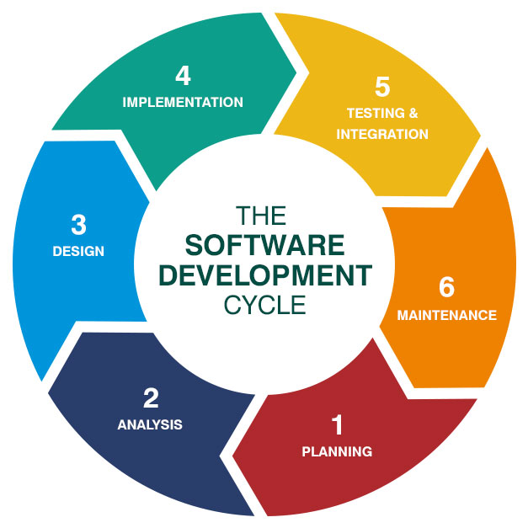

### Stage 1: Planning and Requirement Analysis

Requirement analysis is the most important and fundamental stage in SDLC. It is performed by the senior members of the team with inputs from the customer, the sales department, market surveys and domain experts in the industry. This information is then used to plan the basic project approach and to conduct product feasibility study in the economical, operational and technical areas.

Planning for the quality assurance requirements and identification of the risks associated with the project is also done in the planning stage. The outcome of the technical feasibility study is to define the various technical approaches that can be followed to implement the project successfully with minimum risks.

### Stage 2: Defining Requirements

Once the requirement analysis is done the next step is to clearly define and document the product requirements and get them approved from the customer or the market analysts. This is done through an **SRS (Software Requirement Specification)** document which consists of all the product requirements to be designed and developed during the project life cycle.

### Stage 3: Designing the Product Architecture

SRS is the reference for product architects to come out with the best architecture for the product to be developed. Based on the requirements specified in SRS, usually more than one design approach for the product architecture is proposed and documented in a DDS – Design Document Specification.

This DDS is reviewed by all the important stakeholders and based on various parameters as risk assessment, product robustness, design modularity, budget and time constraints, the best design approach is selected for the product.

A design approach clearly defines all the architectural modules of the product along with its communication and data flow representation with the external and third party modules (if any). The internal design of all the modules of the proposed architecture should be clearly defined with the minutest of the details in DDS.

### Stage 4: Building or Developing the Product

In this stage of SDLC the actual development starts and the product is built. The programming code is generated as per DDS during this stage. If the design is performed in a detailed and organized manner, code generation can be accomplished without much hassle.

Developers must follow the coding guidelines defined by their organization and programming tools like compilers, interpreters, debuggers, etc. are used to generate the code. Different high level programming languages such as C, C++, Pascal, Java and PHP are used for coding. The programming language is chosen with respect to the type of software being developed.

### Stage 5: Testing the Product

This stage is usually a subset of all the stages as in the modern SDLC models, the testing activities are mostly involved in all the stages of SDLC. However, this stage refers to the testing only stage of the product where product defects are reported, tracked, fixed and retested, until the product reaches the quality standards defined in the SRS.

### Stage 6: Deployment in the Market and Maintenance

Once the product is tested and ready to be deployed it is released formally in the appropriate market. Sometimes product deployment happens in stages as per the business strategy of that organization. The product may first be released in a limited segment and tested in the real business environment (UAT- User acceptance testing).

Then based on the feedback, the product may be released as it is or with suggested enhancements in the targeting market segment. After the product is released in the market, its maintenance is done for the existing customer base.

**13. PROJECT MANAGEMENT METHODOLOGY**

A project management methodology is a charted-out roadmap that leads to the successful execution of a project. It contains tools, software, guidelines, and resources that project managers require to plan, manage and monitor deliverables successfully.

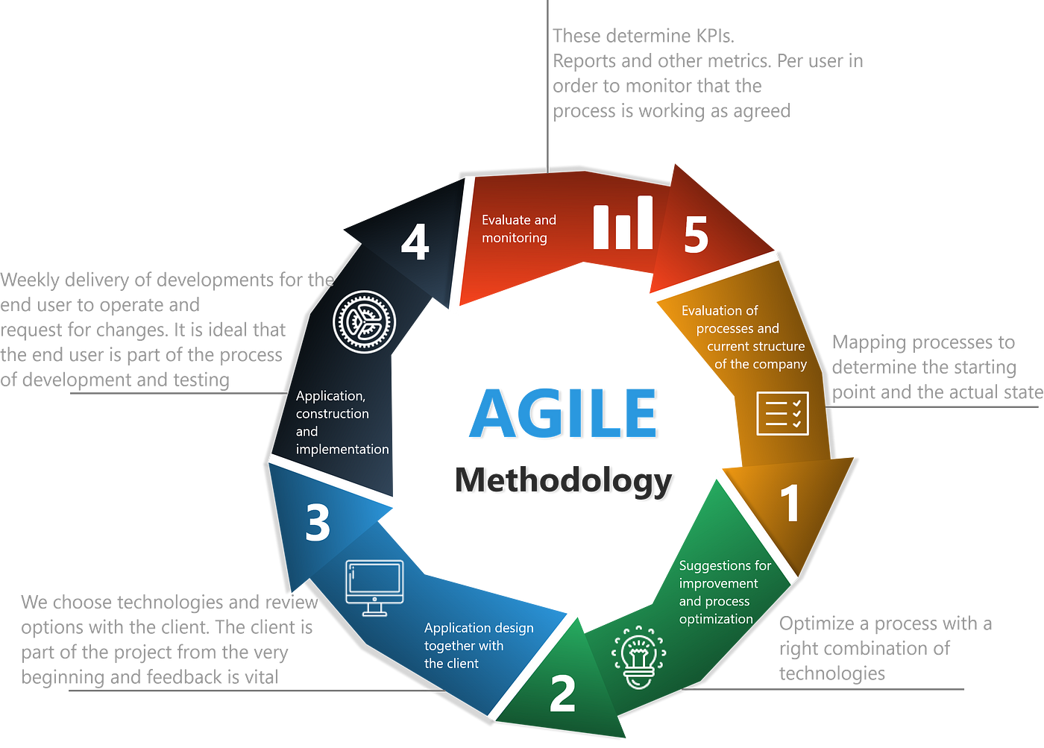

**14. DESIGN CONSIDERATIONS**

• Simplicity

• Visual Hierarchy

• Navigability

• Consistency

• Responsively

• Accessibility

• Conventionality

• Credibility

**1) Simplicity**

While the look and feel of your website is important, most visitors aren't coming to your site to evaluate how slick the design is. Instead, they're coming to your site to complete some action, or to find some specific piece of information.

From a usability and UX perspective, simplicity is your friend. And you can employ simplicity in a variety of different ways. Here are some examples:

* **Colors.**Don't use too many colors in your website's design.
* **Typefaces.** The typefaces you choose should be legible at the very least. And when it comes to colors, you shouldn't use too many. A common recommendation is to use a maximum of three different typefaces in a maximum of three different sizes.
* **Graphics.** Only use them if they'll help a user complete a task or perform a specific function (don't just add graphics willy-nilly).

**2) Visual Hierarchy**

Closely tied to the principle of simplicity, visual hierarchy entails arranging and organizing website elements so that visitors naturally gravitate toward the most important elements first.

Remember, when it comes to optimizing for usability and UX, the goal is to lead visitors to complete a desired action, but in a way that feels natural and enjoyable. By adjusting the position, color, or size of certain elements, you can structure your site in such a way that visitors will be drawn to those elements first.

**3) Navigability**

Having intuitive navigation on your site is crucial for ensuring visitors can find what they're looking for. Ideally, a visitor should be able to arrive on your site and not have to think extensively about where they should click next -- moving from point A to point B should be as pain-free as possible.

**4) Consistency**

In addition to keeping your site's navigation consistent, the overall look and feel of your site should be consistent across all of your site's pages. Backgrounds, color schemes, typefaces, and even the tone of your writing are all areas where being consistent can have a positive impact on usability and UX.

**5) Accessibility**

Accessebility is key to a website. A website is created so that many users can use the site. If it is not accessabile to large population then the sole purpose of the website is wasted.

At a lower level, improving accessibility can be as simple as adding alt-text to all of your images (so visitors who can't see images in their browsers can still understand what's on the page).

**6) Conventionality**

A big challenge in web design is balancing originality with your expectations. Conventions include:

Placing the main navigation at the top (or Left side) of a page. Placing a logo at the top left (or center) of a page.

Making the logo clickable, so it always brings a visitor back to the home page. Having links and buttons that change color/appearance when you hover over them.

**7) Credibility**

Ultimately, using web design conventions -- design elements and strategies that visitors are already familiar with -- can help give your site more credibility. And if you're striving to build a site that provides the best user experience possible, credibility (a.k.a. the amount of trust your site conveys) can go a long way.

One of the best ways to improve your site's credibility is to be clear and honest about the product/service you're selling on the site.

**8) User-Centricity**

At the end of the day, usability and user experience hinge on the preferences of the end users. (After all, if you're not designing for them ... whom are you designing for?)

So while the principles detailed in this list are a great starting point, the real key to improving the design of your site is to conduct user testing, gather feedback, and make changes based on what you've learned.

**15. DEPLOYMENT METHODS AND CONTIGENCIES**

Technology is defined as a comprehensive process based on the application of science and knowledge in many areas of life in an orderly and thoughtful manner in order to achieve important and valuable purpose for individuals and communities.

**HTML:**

HTML is a markup language that defines the structure of your content. HTML consists of a series of elements which you use to enclose, or wrap, different parts of the content to make it appear a certain way, or act a certain way. The enclosing tags can make a word or image hyperlink to somewhere else, can italicize words, and can make the font bigger or smaller, and so on.

**Cascading Style Sheets (CSS):**

CSS is the first technology you should start learning after HTML. While HTML is used to define the structure and semantics of your content, CSS is used to style it and lay it out. For example, you can use CSS to alter the font, color, size, and spacing of your content, split it into multiple columns, or adds animations and other decorative features.

**Bootstrap:**

Bootstrap is  **a free, open source front-end development framework for the creation of websites and web apps**. Designed to enable responsive development of mobile-first websites, Bootstrap provides a collection of syntax for template designs.

**JavaScript:**

JavaScript is a programming language that allows you to implement complex functionalities on web pages. Every time a web page does more than just sit there and display static information for you to look at-displaying timely content updates, interactive maps, animated2D and 3D graphics, scrolling video jukeboxes, or more. You can bet that JavaScript is involved.

**PHP:**

PHP (Hypertext Preprocessor) is a widely-used open source general-purpose scripting language that is especially suited for web development and can be embedded into HTML.

**MySQL:**

MySQL is one of the most recognizable technologies in the modern big data ecosystem. Often called the most popular database and currently enjoying widespread, effective use regardless of industry, it’s clear that anyone involved with enterprise data or general IT should at least aim for a basic familiarity of MySQL.

**16. DETAILED DEVELOPMENT PROCESS**

**HTML:**

HTML is a text file containing specific syntax, file and naming conventions that show the computer and the web server that it is in HTML and should be read as such. By applying these HTML conventions to a text file in virtually any text editor, a user can write and design a basic webpage, and then upload it to the internet.

The most basic of HTML conventions is the inclusion of a document type declaration at the beginning of the text file. This always comes first in the document, because it is the piece that affirmatively informs a computer that *this is an HTML file.* The document header typically looks like this: <!DOCTYPE html>. It should always be written that way, without any content inside it or breaking it up. Any content that comes before this declaration will not be recognized as HTML by a computer.

**JavaScript:**

JavaScript is a client-side scripting language and one of the most efficient, commonly used scripting languages. The term .**client-side scripting language means** that it runs at the client-side( or on the client machine) inside the web-browsers, but one important thing to remember is that client's web-browser also needs to support the JavaScript or it must be JavaScript enabled. Nowadays, most of the modern web browsers support JavaScript and have their JavaScript engines. For example, Google Chrome has its own JavaScript engine called V8.

This was especially used to set the time and score in the system.

**Bootstrap:**

Bootstrap makes responsive web design a reality. It makes it possible for a web page or app to detect the visitor's screen size and orientation and automatically adapt the display accordingly. The mobile-first approach assumes smartphones, tablets and task-specific mobile apps are employee’s primary tools for getting work done. Bootstrap addresses the requirements of those technologies in design and includes UI components, layouts, JavaScript tools and the implementation framework. The software is available precompiled or as source code.

Mark Otto and Jacob Thornton developed Bootstrap at Twitter to improve the consistency of tools used on the site and to reduce maintenance. The software was formerly known as Twitter Blueprint and is sometimes referred to as Twitter Bootstrap.

**How do web servers work?**

Web server software is accessed through the domain names of websites and ensures the delivery of the site's content to the requesting user. The software side is also comprised of several components, with at least an HTTP server. The HTTP server is able to understand HTTP and URLs. As hardware, a web server is a computer that stores web server software and other files related to a website, such as HTML documents, images and JavaScript files.

When a web browser, like Google Chrome or Firefox, needs a file that's hosted on a web server, the browser will request the file by HTTP. When the request is received by the web server, the HTTP server will accept the request, find the content and send it back to the browser through HTTP.

More specifically, when a browser requests a page from a web server, the process will follow a series of steps. First, a person will specify a URL in a web browser's address bar. The web browser will then obtain the IP address of the domain name -- either translating the URL through DNS (Domain Name System) or by searching in its cache. This will bring the browser to a web server. The browser will then request the specific file from the web server by an HTTP request. The web server will respond, sending the browser the requested page, again, through HTTP. If the requested page does not exist or if something goes wrong, the web server will respond with an error message. The browser will then be able to display the webpage.

NON-Application server:

Non-Application server is a server that hosts applications or software that delivers a business application through a communication protocol.

An application server framework is a service layer model. It includes software components available to a software developer through an application programming interface. An application server may have features such as clustering, fail-over, and load-balancing. The goalies for developers to focus on the business logic.

Web application architecture defines the interactions between applications, middleware systems and databases to ensure multiple application scan work

together. When a user types in a URL and taps “Go, ” the browser will find the Internet-facing computer the website live soon and requests that particular page.

The server then responds by sending files over to the browser. After that action, the browser executes those files to show the requested page to the user. Now, the user gets to interact with the website. Of course, all of these actions are executed within a matter of seconds. Otherwise, users wouldn’t bother with websites.

What’s important here is the code, which has been parsed by the browser. This very code may or may not have specific instructions telling the browser how to react to a wide range of inputs. As a result, web application architecture includes all sub-components and external applications interchanges for an entire software application.

Of course, it is designed to function efficiently while meeting its special goals. Web application architecture is critical since the majority of global network traffic, and every single app and device uses web-based communication .It deals with scale, efficiency, robustness, and security.

**HOW WEB APPLICATION ARCHITECTURE WORKS.**

**Web application architecture** is a mechanism that determines how application components communicate with each other. Or, in other words, the way the client and the server are connected is established by web application architecture.

Web applications of different sizes and complexity levels all follow the same architectural principle, but details may differ. We will further explain how a basic request-response process works and what components comprise the architecture.

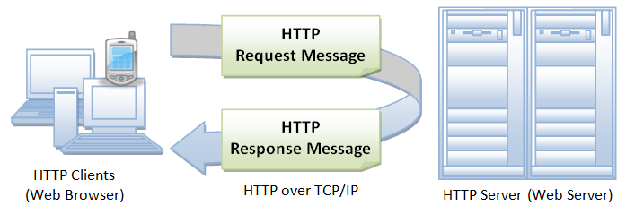

**REQUEST AND RESPONSE:**

As we start to build out web applications, it is important to be able to visualize the way information flows through the system; typically called the Request/Response Cycle.

First a user gives a client a URL, the client builds a **request** for information (or resources) to be generated by a server. When the server receives that request, it uses the information included in the request to build a **response** that contains the requested information. Once built, that response is sent back to the client in the requested format, to be rendered to the user.

**17. REGISTRATION-PAGE**

To start with the project, our team and I have decided to work on the registration page first for our application. Without registration students cannot enter the site.

Here candidates must enter their details such as first name, last name, e-mail, phone number, address, gender, password, country etc. Filling the information and clicking on register will let these details be saved in the database. For this PHP and database are used.

These details will be saved in database so that the user can login later.

This also contains a link saying “Do you already have an account? Login” which takes you to the login page.

The image displayed below is the registration page of the site.

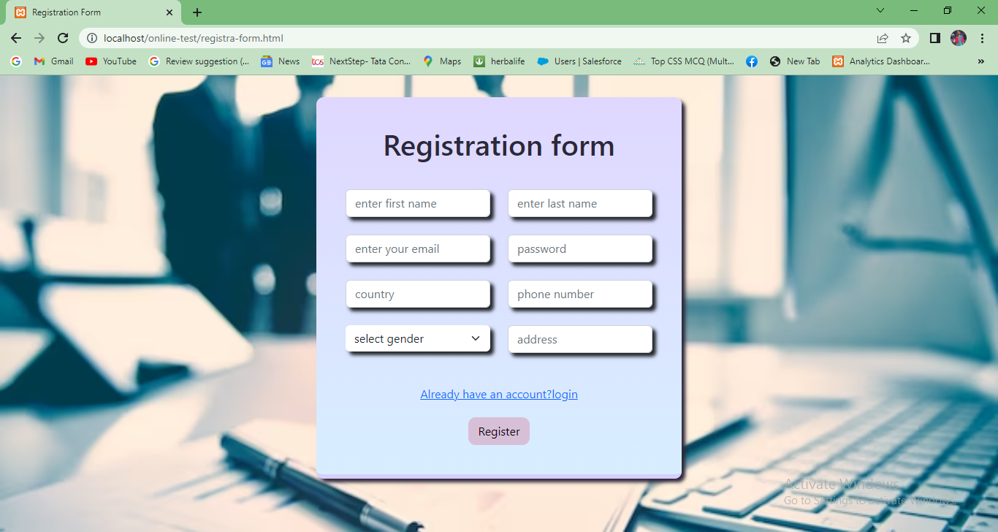

If you are successfully registered in the site the image below will be displayed.

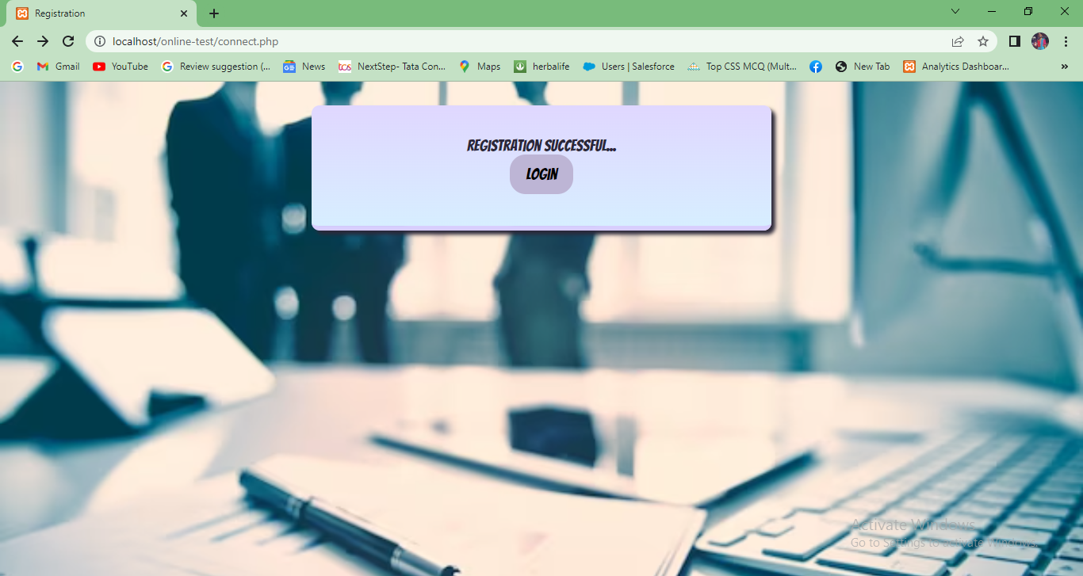

**18. LOGIN**

Whenever a user submits their login credentials they can enter the site. This form has the fields e-mail and password. The candidates enter their details if they are already registered. The login credentials will be validated by comparing them with the database.

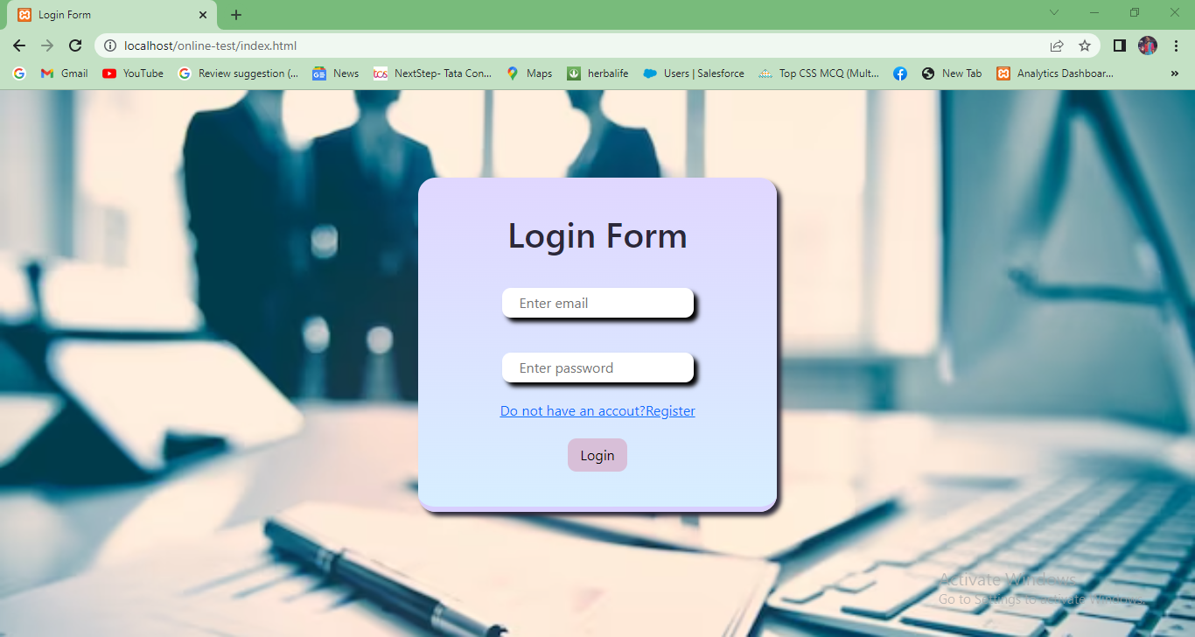

There is link below saying “Do not have an account? Register” Clicking on this will let the candidate go to the registration page.

If the given details are correct you will be successfully logged in and you can go to the next page.

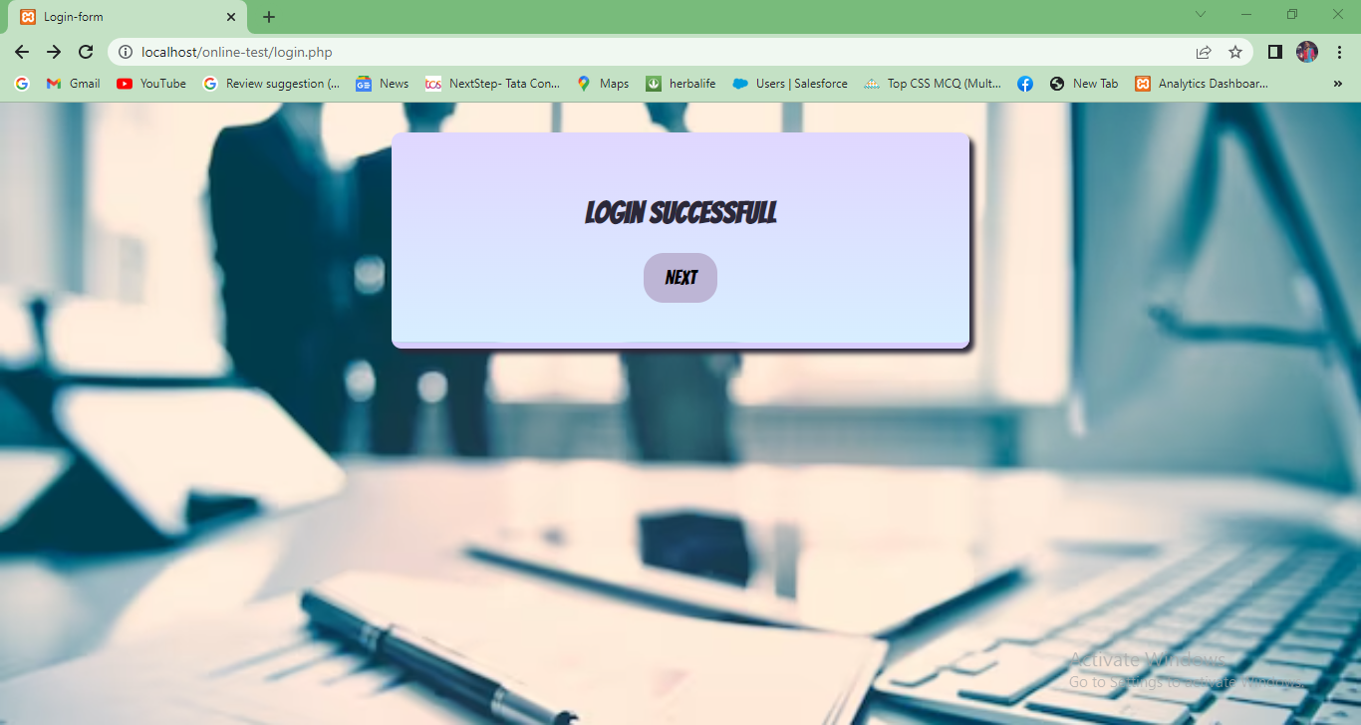

If the details are incorrect the user will be notified about it and they can try entering their details again.

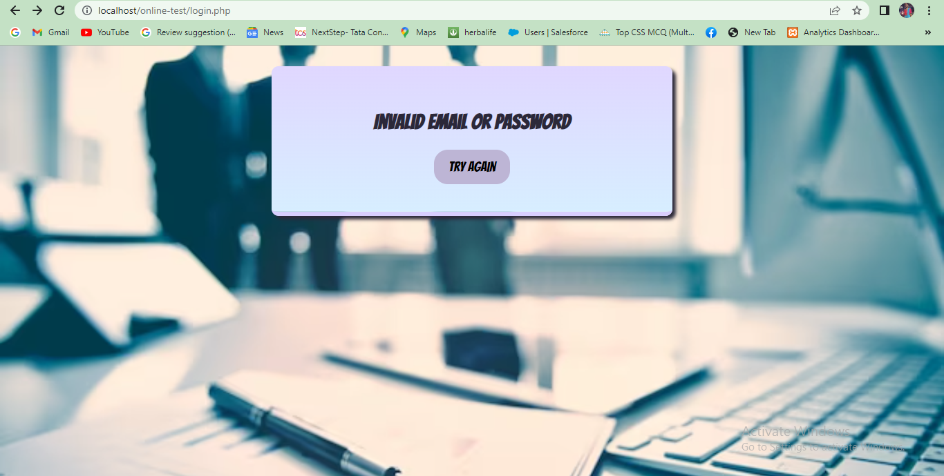

**19. HOME PAGE**

After submitting the details and clicking on the login button you will be shown the home page. In the home page you can see the navigation bar where we have generate paper and generated paper displayed. Clicking on them will take you to the respective pages.



We can see a carousel where images are being displayed. Below that you can see some content about our site where we described about our site. Down here you can see more images of the site.

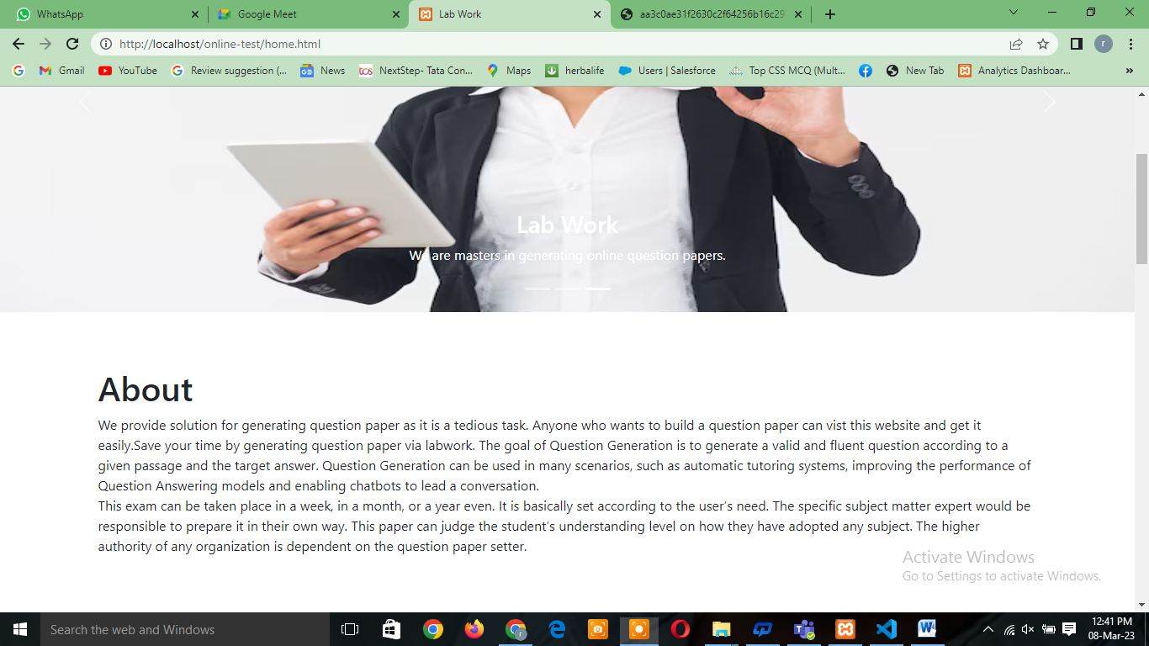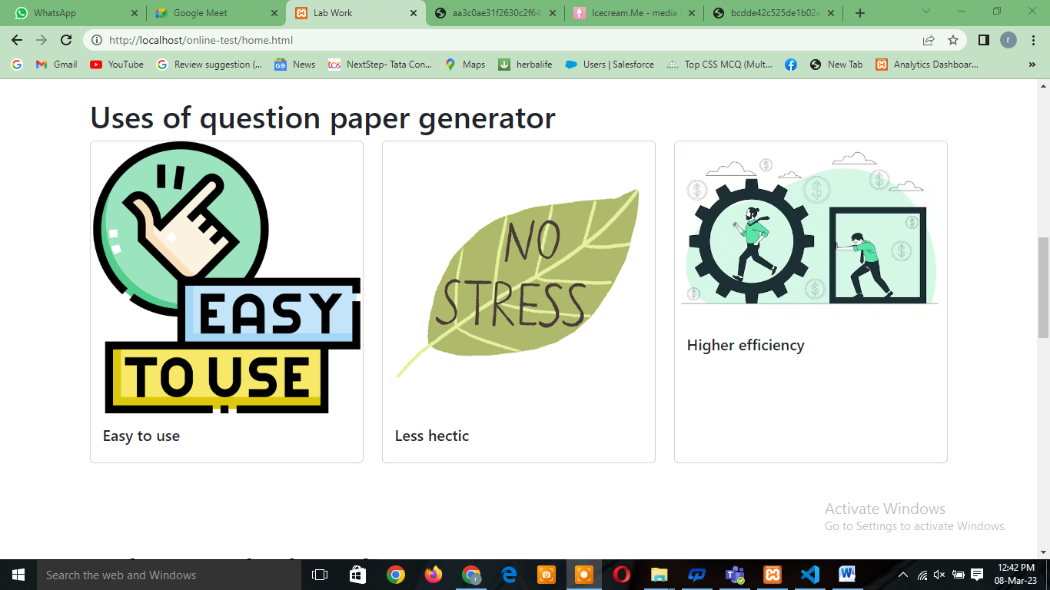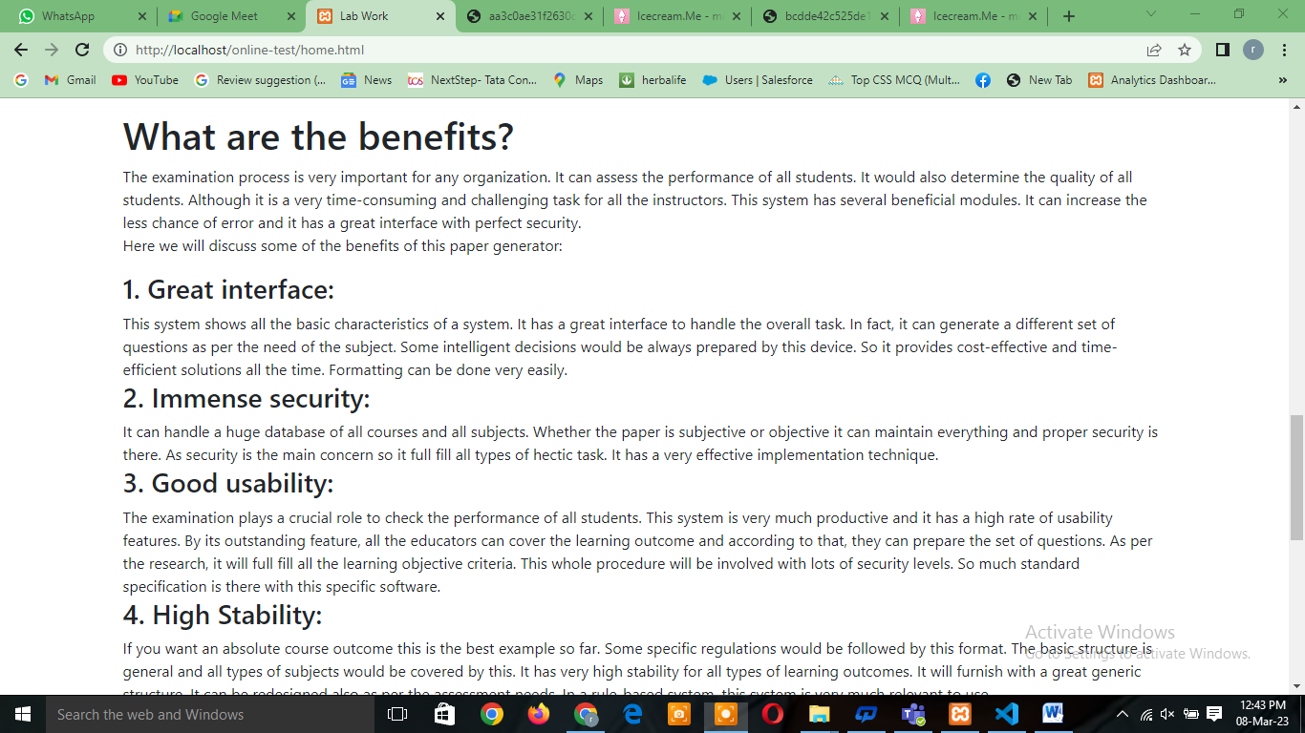

**20. Generate paper**

Here the user enters the details of the form like question paper name, max marks, time, paper number, question number, its options. When the user enters the details here these details will be saved in the database. After being saved in the database these tables will be saved and displayed.

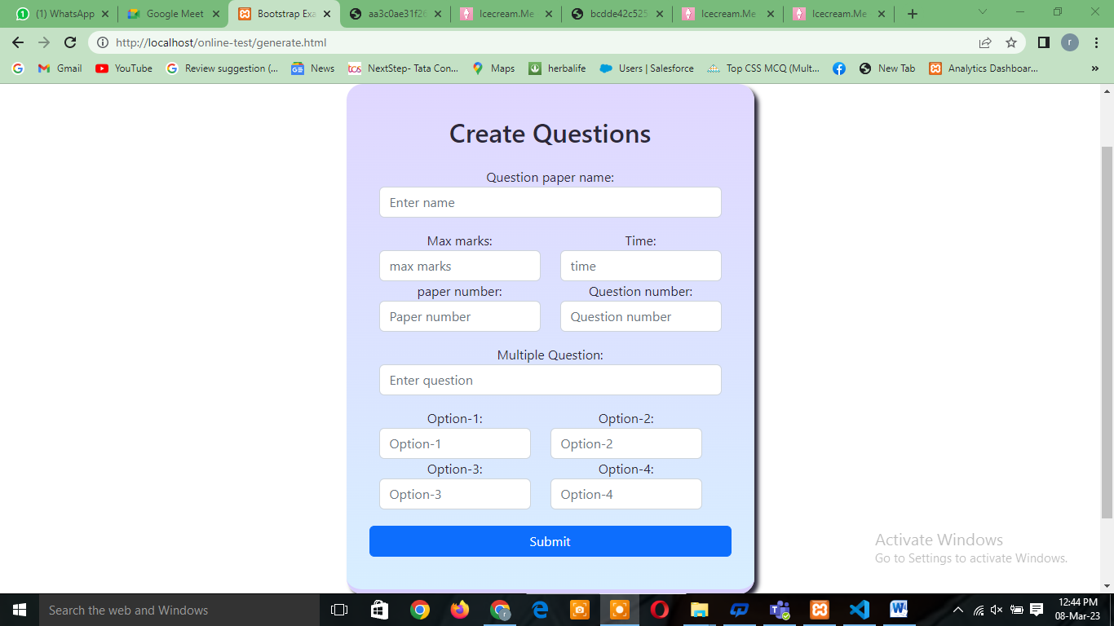

**21. GENERATED PAPER**

After entering the details in the generate paper form and submitting it will be saved in the data base. This saved data will be displayed in this page as questions.

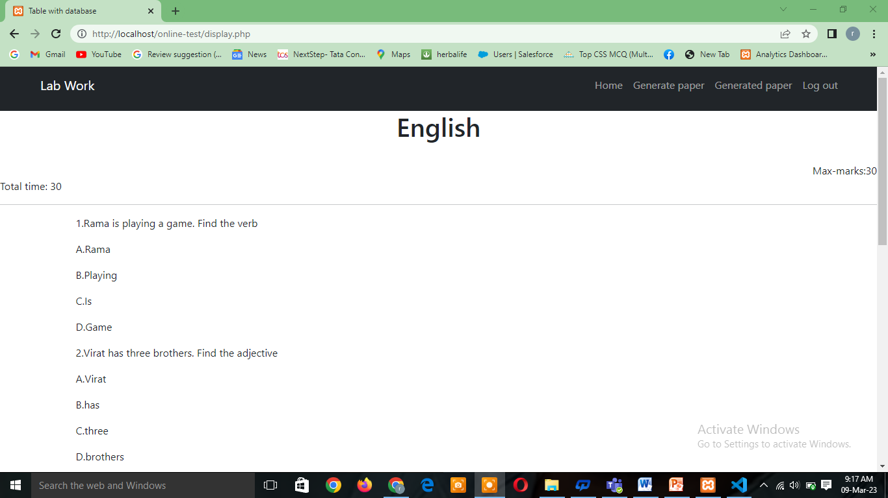

**22. MOCK TESTS**

Exam pressure is real. No matter how prepared, and ready for the exam you feel, the real exam condition can be intimidating. And, sometimes the pressure in real exam conditions makes students anxious which in turn hampers the performance or results.  
Then, what is the solution? How can students ensure they don’t get caught in exam pressure?  
The answer to this is to practice Mock Tests!  
Mock tests are exams that are prepared on guidelines same as real exams. These follow the same pattern, set of questions, difficulty level, and also time limits. And just because these mimic the real exam, these are called “Mock” tests!  
No matter if you are preparing for your upcoming board exams, or are in the competitive exam preparations, you can practice mock tests. There is a range of mock tests available online. And, one can also get mock test books from bookstores.  
Mock test meaning is not just practicing for the exam, but it lets you feel how the exam paper is going to look like. It prepares you for the real show.

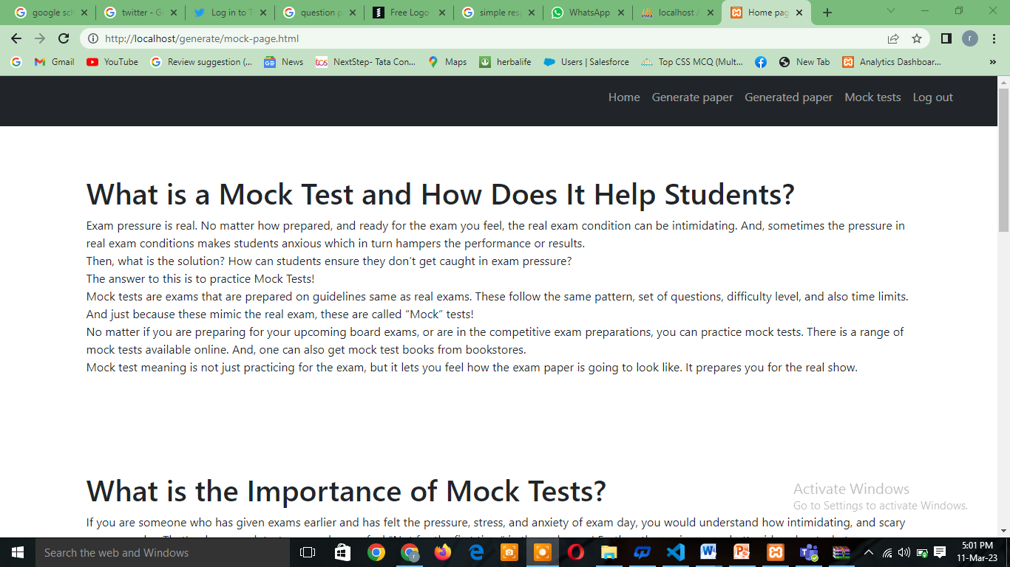

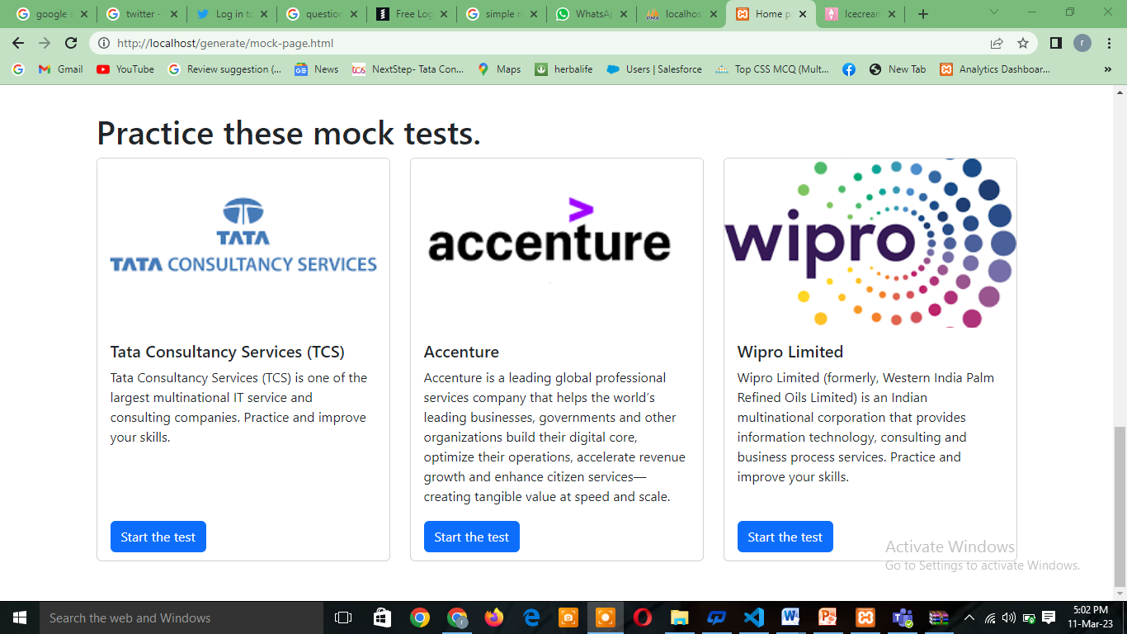

Currently there are three sample test sets of Wipro, Accenture, and TCS in which you might be given any set. Each set contains three sections namely English, Aptitude and Coding. Each test has a fixed amount of time.

Score for English and Aptitude will be displayed immediately after writing the exam. For this we used JavaScript. We also used JavaScript to set the timer (you can see it at the top of the page) and linked them with the scoring system. So whenever the time runs out the page will be automatically submitted and move to the next page.

Here is the Wipro test as an example. We also have other tests just like this.

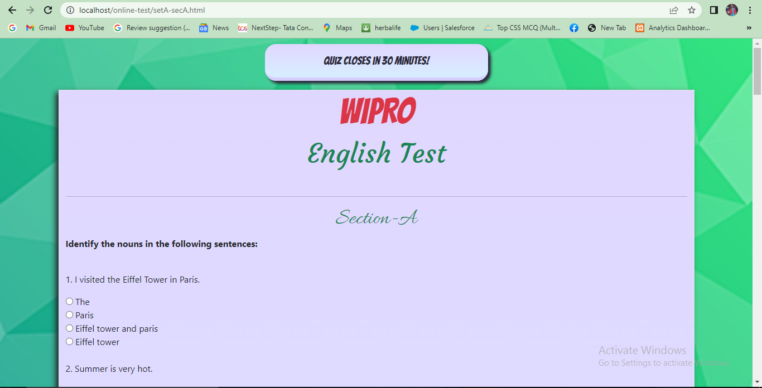

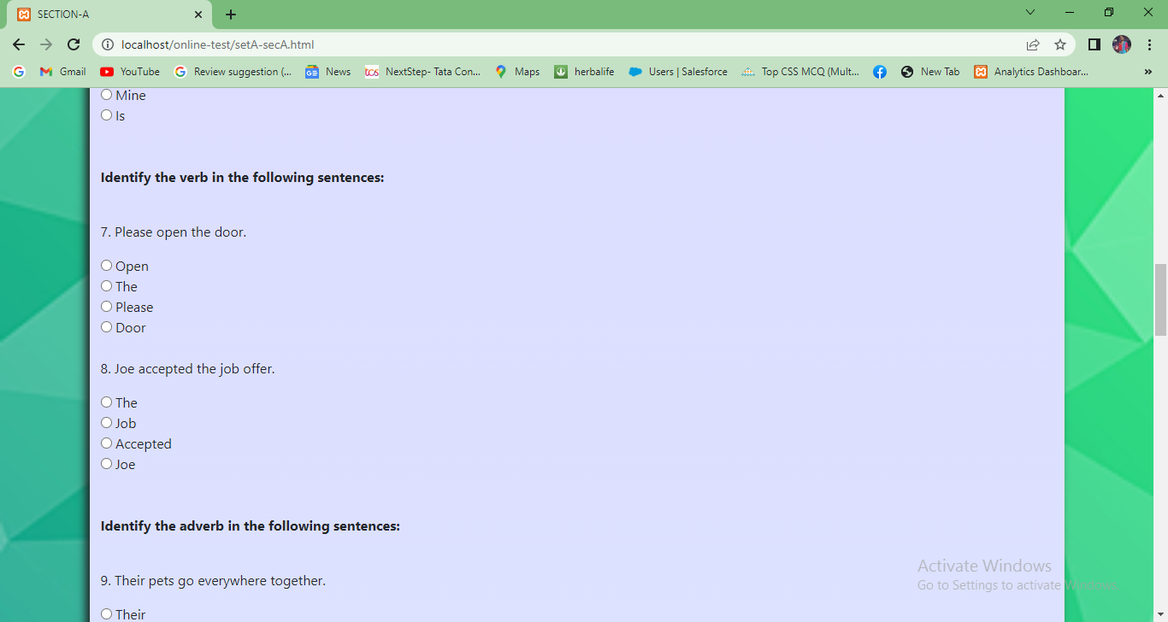

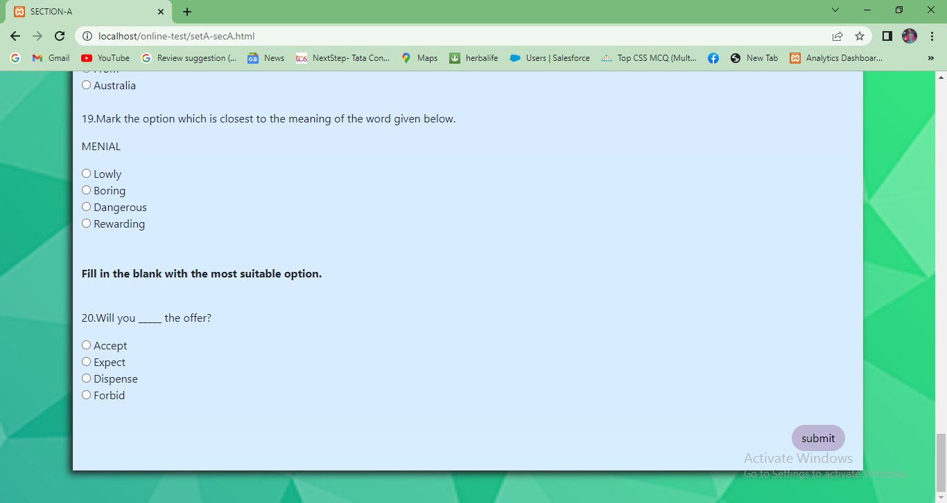

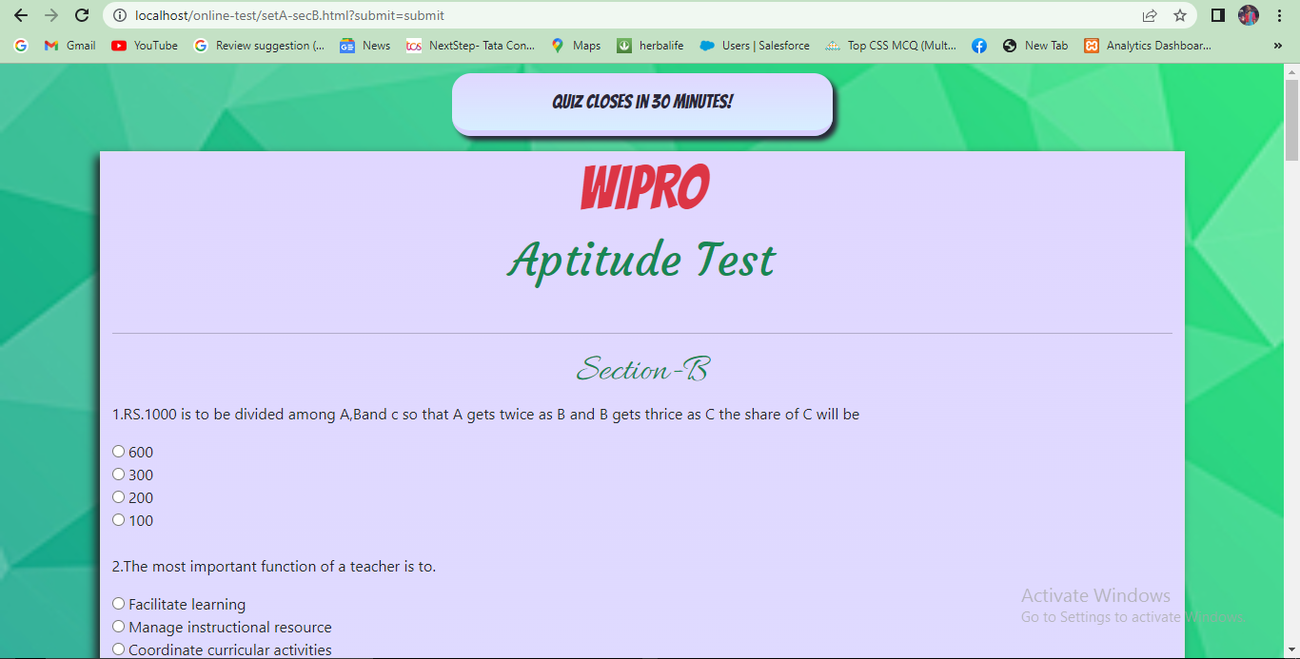

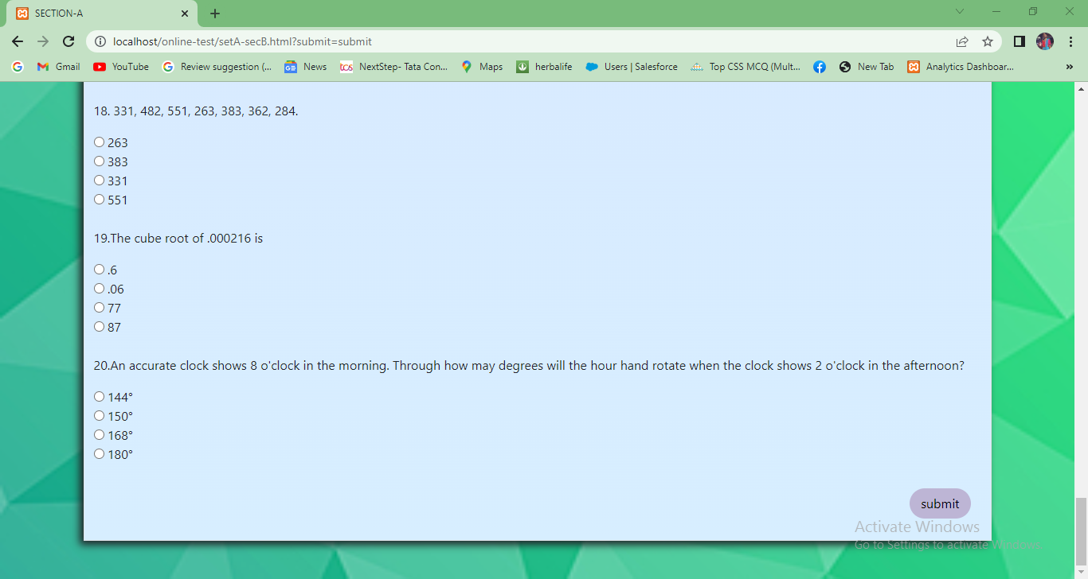

*After clicking on submit result will be displayed to you.*

**23. RESULT PAGE**

If you pass the test the site will show the result like the picture displayed below. If you fail the test the site will show the result like the picture displayed below.

Here JavaScript is used to create the button. Here window.location.href is used to connect to a different page.

Image that shows the results after passing test.

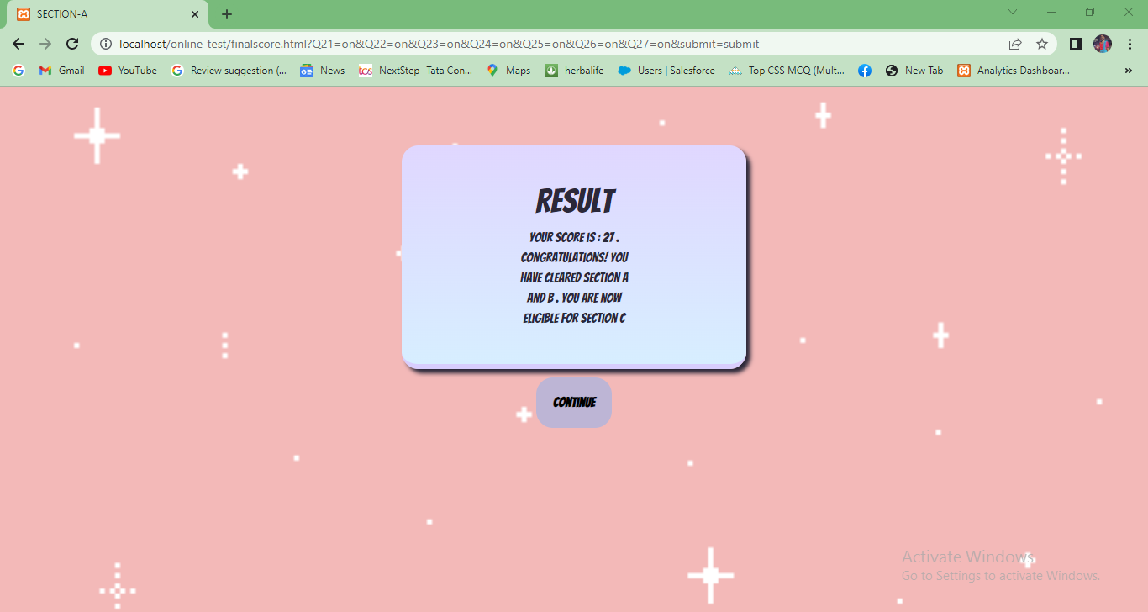

Image that shows the results after failing test.

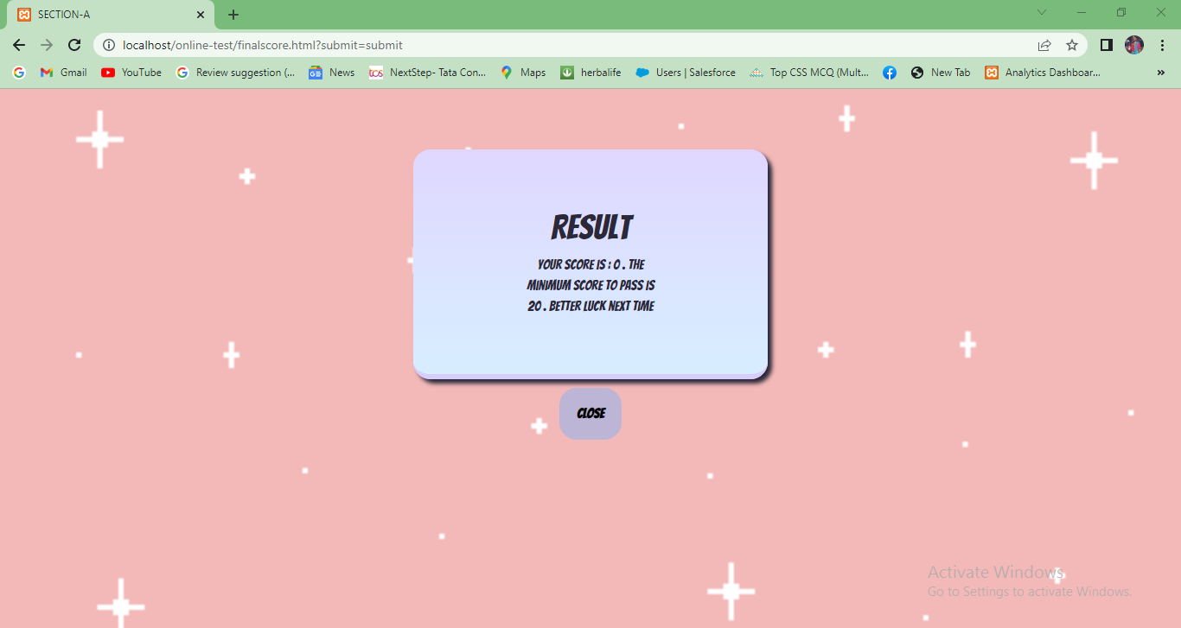

**24. FEASABILITY STUDY**

A feasibility study is a comprehensive evaluation of a proposed project that evaluates all factors critical to its success in order to assess its likelihood of success. Business success can be defined primarily in terms of ROI, which is the amount of profits that will be generated by the project.

### 1. Technical Feasibility

This assessment focuses on the technical resources available to the organization. It helps organizations determine whether the technical resources meet capacity and whether the technical team is capable of converting the ideas into working systems. Technical feasibility also involves the evaluation of the hardware, software, and other technical requirements of the proposed system. As an exaggerated example, an organization wouldn’t want to try to put Star Trek’s transporters in their building—currently; this project is not technically feasible.

### 2. Economic Feasibility

This assessment typically involves a cost/ benefits analysis of the project, helping organizations determine the viability, cost, and benefits associated with a project before financial resources are allocated. It also serves as an independent project assessment and enhances project credibility—helping decision-makers determine the positive economic benefits to the organization that the proposed project will provide.

### 3. Operational Feasibility

This assessment involves undertaking a study to analyze and determine whether—and how well—the organization’s needs can be met by completing the project. Operational feasibility studies also examine how a project plan satisfies the requirements identified in the requirements analysis phase of system development.

**25. TESTING / QA / UAT**

Application is tested in different environment before deployment to production zone.

Following test processes followed in entire cycle of the SDLC.



**Unit testing**: Application is tested by each module /page by developer independently to identify bugs in each code block.

**Integration testing**: Application testing is performed after integration of all modules and tested each functionality and fixed by developers as part of the process.

**Code review**: Code review happens when another developer goes through your or your team's code line-by-line and provides constructive, helpful feedback. Code review saves time and effort by ensuring code quality up-front, rather than waiting until issues are discovered in production.

**QA**: Quality Assurance (QA) ensures that end- users get a functional user interface and the best user experience when using a web app or website. It examines a website or web application to try and uncover any flaws that might have been overlooked during design and development.

**UAT:** User Acceptance Testing (**UAT**), otherwise known as Application, Beta, or End-User Testing, is a stage in the software development process that is performed by the end-user, after functional testing, integration testing, regression testing, and system testing is done. It’s the last phase of the software testing process. Throughout the software development lifecycle (SDLC), theproductundergoesvarioustypesoftestingbythetestingteamanddevelopers.UAT is a testing activity to verify that the developed product is working properly, and the implemented functionalities are easy to find. It is not only the usability of the product that is being tested at this stage but also the software itself; actual software users test the product to ensure it can handle required tasks in real-world scenarios, according to specifications and provide the best user experience.

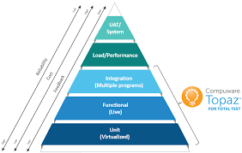

**26. PROCESS DIAGRAMS**

**Class diagram :**

Class diagram is the main building box of object- oriented modelling. General conceptual modeling of the structure of the application, and for detailed modeling translating the models into programming code was done using this.

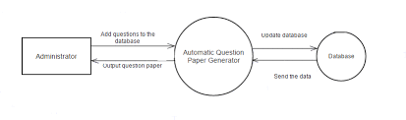

Data Flow Diagram

DFD for Registration

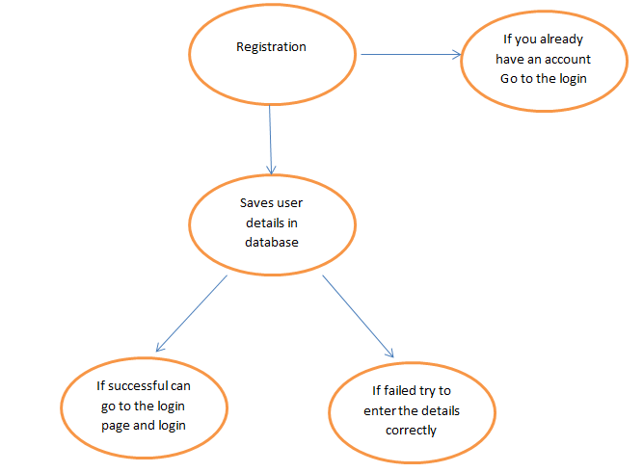

DFD for Login

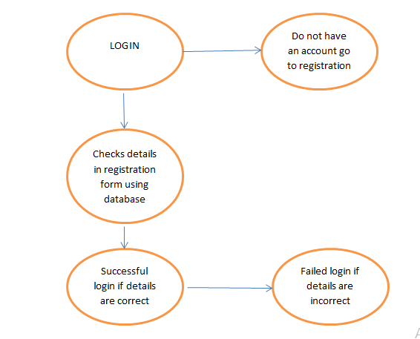

DFD for mock test

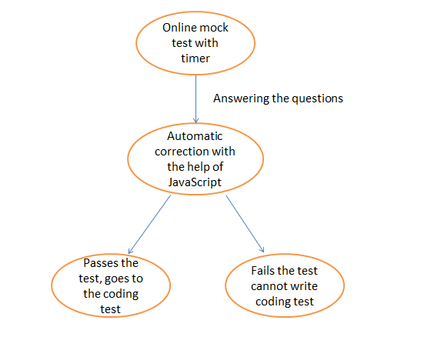

**ER Diagram**

This ER (Entity Relationship) Diagram represents the model of online recruitment mock test system. The entity-relationship diagram of Question paper generator shows all the visual instrument of database tables and the relations between users and answers etc. It used structure data and to define the relationships between structured data groups of Question paper generator functionalities. The main entities of the Question paper generator are email, password, question paper name, number and questions.

Database tables

Registration table

|  |  |  |  |
| --- | --- | --- | --- |
| Field | Type | Constraint | Description |
| **ID** | Int | Not null | Serial number |
| **First name** | Varcar(50) | Not null | First name |
| **Last name** | Varcar(50) | Not null | Last name |
| **Email** | Varcar(50) | Not null | User email |
| **Password** | Varcar(50) | Not null | User password |
| **Phone number** | Varcar(50) | Not null | User number |
| **Gender** | Varcar(50) | Not null | User gender |
| **Address** | Varcar(50) | Not null | address |
| **Country** | Varcar(50) | Not null | country |

Generate paper table

|  |  |  |  |
| --- | --- | --- | --- |
| Field | Type | Constraint | Description |
| Id | Int | Not null | serial number |
| Paper_name | Medium text | Not null | Name of paper |
| Max_marks | Medium text | Not null | Maximum marks |
| time | Medium text | Not null | Time of paper |
| Paper_no | Int | Not null | Paper number |
| Question_no | Int | Not null | Question number |
| question | Varcar | Not null | Question |
| Op1 | Varcar | Not null | First option |
| Op2 | Varcar | Not null | Second option |
| Op3 | Varcar | Not null | Third option |
| Op4 | Varcar | Not null | Fourth option |

**27. SECURITY**

The security measures have been taken in a bid to make the software full proof in terms of various activities:

* **Keep Software And Plugins Up-To-Date**
* **Add HTTPS and an SSL Certificate**
* **Choose a Smart Password**
* **Use a Secure Web Host**
* **Record User Access and Administrative Privileges**
* **Change Your CMS Default Settings**

These are the few measures that are considered to meet the security measures while developing a project for an organization.

**28. SAMPLE CODE**

**Login page**

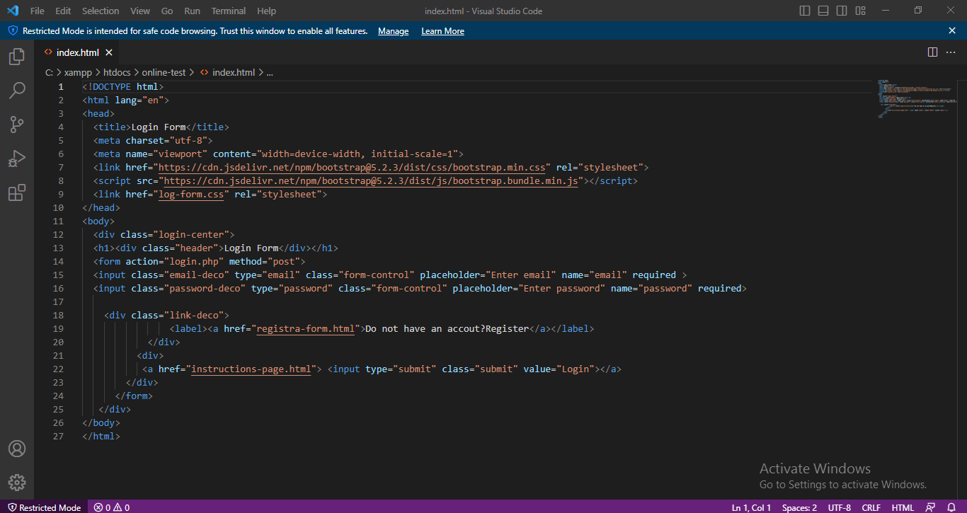

Registration page PHP:

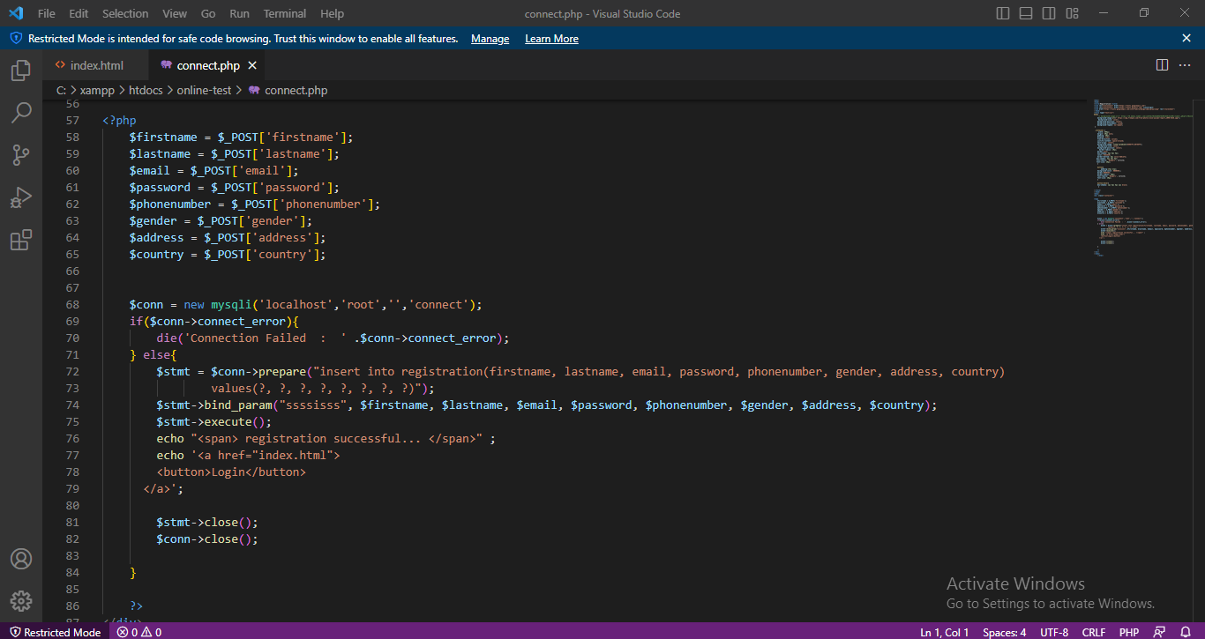

Home page

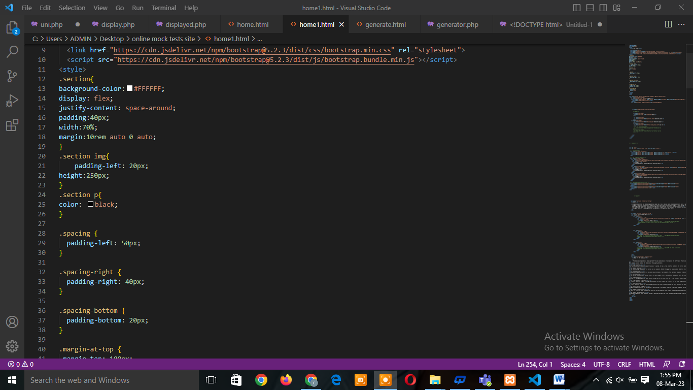

Display questions

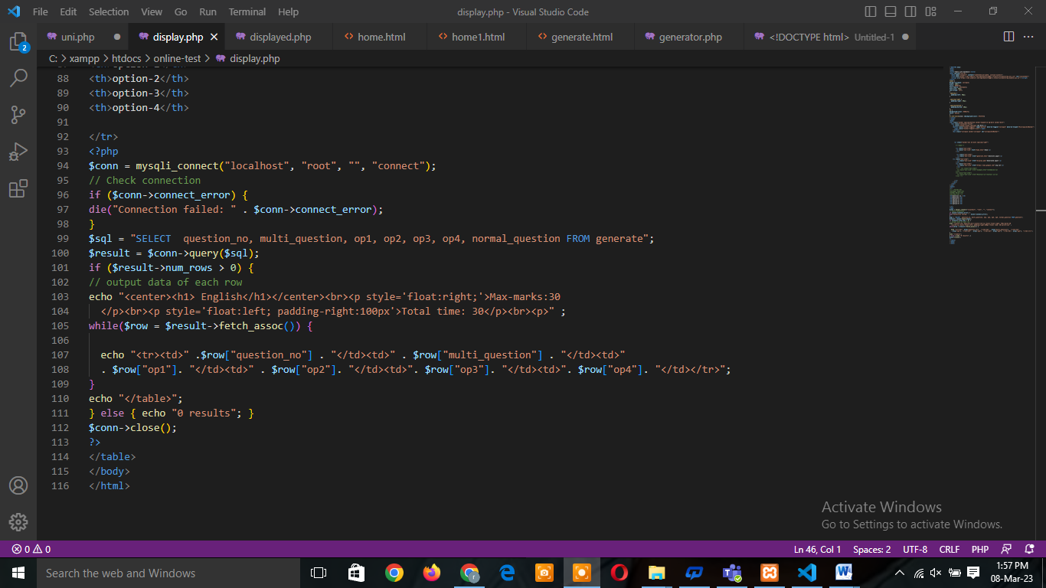

**29. FUTURE SCOPE**

* We want to generate questions automatically just after they explain the topic of the exam.
* We want to use artificial intelligence to search the right questions for the user. Create more than one paper at a time with this system.
* We also want to add some mock tests in our site which are connected automatically.
* We also want to add better security system to our website.
* We also want to set the level of difficulty so that the user can know what questions they want to give.
* Along with mock tests we also want to add mock interviews so the candidates can get a job at ease.
* Right now we only have mock tests of recruitment tests in future we also want to add entrance exams of master’s degrees and other important tests.

**28. IMPLEMENTATION AND MAINTENANCE**

Once the Web site testing is complete and any required changes have been made, the Website can be implemented. Implementation of a Web site means publishing the Website or uploading in to a Webserver.

Once, the Website has been implemented, its maintenance will include updating the information content by removing the outdated one and putting in the new one.

Periodical checking of the links is also necessary to ensure that they are still active.

We are also putting a contact us link at the footer so the user can personally email us about their queries. They can also contact us for some services.

**29. CONCLUSION**

This is a web-Based System. Our future effort is to employee different types of randomization as well as addition to Question Generation, we can enhance the same software by making provision to produce question from online test. This system can emphasize more percentage of difficulty when question papers are referred from this repository.

Our site provides sample online test papers of different companies so that people who are trying for jobs can get the job with ease. This site contains registration form, login forms where details should be filled to enter the site, instructions page, sample test papers which are auto generated, and result pages.

**30. BIBLIOGRAPHY**

* <https://www.google.com/?&hl=en>
* <https://scrimba.com/>
* <https://www.w3schools.com/>
* <https://developer.mozilla.org/en-US/>
* <https://stackoverflow.com/>